Pakistan-US-Iran Conflict Prediction Model

Key Insights Report

Section 1 — Pakistan's Security & Geopolitical Position
- Pakistan ranks 7th globally in total conflict fatalities (56K fatalities, 19K events) — behind Afghanistan, Yemen, Syria, Iraq, Myanmar, and Palestine, but ahead of Iran, Philippines, and India
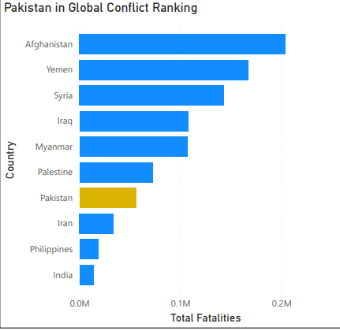
- Pakistan's fatality growth rate is 2.86% YoY — rising security burden while maintaining active diplomacy
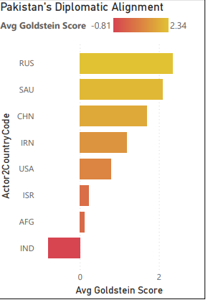
- India is Pakistan's only net-negative major relationship (Goldstein score: -0.81), confirming the India-Pakistan rivalry as the dominant structural constraint
- Both Iran (+1.19) and USA (+0.78) register positive scores — this balanced positioning is what makes Pakistan a viable mediator
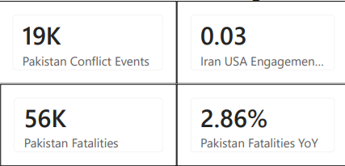

Section 2 — Pakistan's Mediation Capacity
- Overall Iran-USA cooperation rate: 0.77; conflict rate: 0.23; diplomacy balance index: 0.54
- Mediation Window Score: 0.80 — Pakistan satisfies the dual-positive condition for most of the study period
- Pakistan's mediation pattern is reactive, not proactive — it increases engagement with Iran and USA after tension spikes, not before. This means diplomatic activation is a lagging confirmation signal, not a leading one
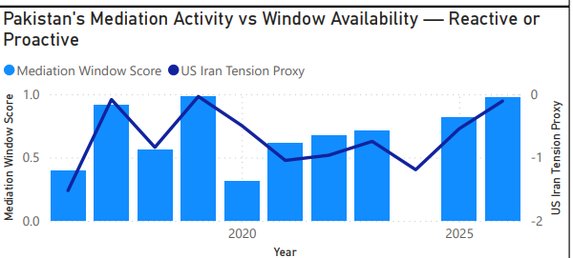
- Verbal cooperation is the dominant mode with both Iran and USA; USA relationship shows slightly more material conflict (reflecting Afghanistan/counterterrorism friction). The USA bar for verbal cooperation is notably higher than Iran’s - Pakistan speaks more publicly to Washington than Tehran, consistent with the public facing nature of the US partnership vs the more bilateral nature of the Iran relationship.
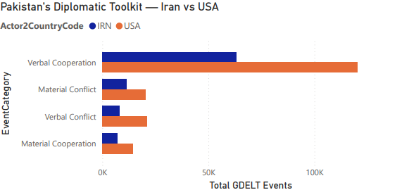

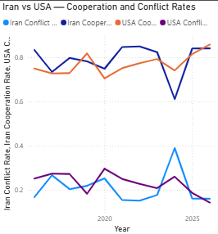
- The four line chart separates Iran and USA cooperation and conflict rates individually. The key moment is 2024 when Iran cooperation rate collapses while USA cooperation rate holds relatively stable. The divergence is the mediation window closing: Pakistan can still work with the USA but has lost its balance point with Iran. This divergence is measured by the Tension proxy measure numerically.

The chart shows mediation activation as a binary 0 or 1 by year. Two activation years visible: approximately 2016 and 2024–2025. The 2024–2025 activation is externally validated — Iran's Foreign Minister credited Pakistan's mediation efforts and Trump confirmed ceasefire conversations with PM Shehbaz Sharif and Field Marshal Asim Munir. The Islamabad Talks (April 11–12, 2026) were led by Pakistan's diplomatic team mediating between US and Iranian delegations.
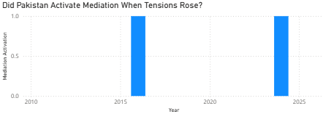

Section 3 — The 2024 Warning Signal
- The mediation window score line overlaid against the US Iran Tension Proxy shows the key structural relationship: when the tension proxy worsens (becomes more negative), the mediation window typically narrows. The 2024 exception — where both collapsed simultaneously — is the crisis signature. When both lines move together toward their worst readings at the same time, that is the complete mediation window closure event.
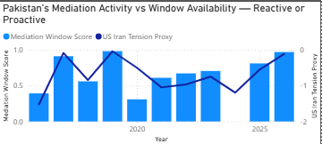
- 2024 was the only year in the dataset where Pakistan's Iran tone turned negative (-2.33) — the first and only complete closure of the mediation window
- Three lines tell three different stories. China (dark blue) stays consistently high at 1.5–2.5 throughout — it never reacts to crises and provides Pakistan's diplomatic stability baseline. Iran (orange) is the most volatile — stable for years then crashing suddenly in 2024, consistent with the structural unpredictability finding. USA (navy) moves more than China but recovers reliably. The key 2024 moment: Iran crashes to −0.9 while USA holds above 0 — Pakistan clearly leaning toward Washington when forced to choose
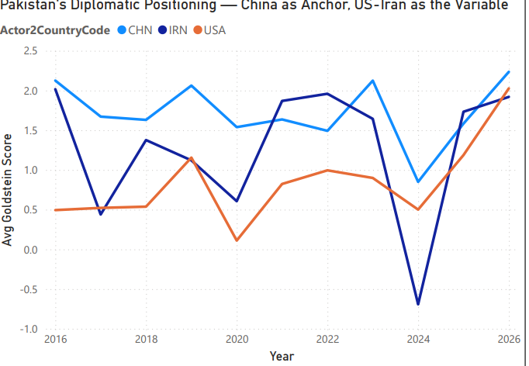
- USA tone simultaneously fell to +0.50; Pre-Crisis Signal Score peaked at +3; Conflict Risk Score reached maximum (4/4)
- All three scoring conditions fired simultaneously: both tone momentums negative, divergence >1, Mediation Window Score <0.3
- This coincided with the Gaza conflict peak (October 2023–2024) and Iran-Israel direct strikes in April and October 2024. The regional Islamic solidarity pressure around Gaza specifically targeted Pakistan's Iran relationship.
- The 2025 recovery — Iran +1.73, USA +1.19 — was the sharpest single-year improvement recorded, suggesting active Pakistani diplomatic intervention following the June 2025 Twelve-Day War ceasefire.
- Current status (2025–2026): Iran tone +1.19, USA tone +0.78, both positive and recovering. Tension Proxy at −0.40 — mild divergence, balance partially restored.
- The JCPOA Withdrawal marker (2018) shows the first diplomatic stress — both Iran and USA tones dip as Pakistan navigates the US pullout from the nuclear deal. The Gaza Conflict marker (2023–2024) shows the catastrophic collapse of Iran tone while USA tone holds. The gap between the two lines at the Gaza marker is the visual representation of the mediation window closing. The post-2024 recovery is visible as both lines rise sharply toward 2026.
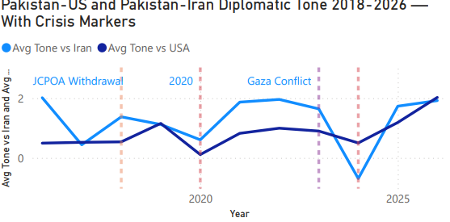

Section 4 — Asymmetric Tone Predictability (Key theoretical finding)
- USA tone is predictable: prior year USA tone closely tracks current year — high continuity.
- Iran tone is structurally unpredictable: the 2024 crash from stable positive to -2.33 was completely unforeseeable from 2023 data.
- This confirms Iran as the volatile actor in the triangle, consistent with existing literature.
- Implication: the model generates stronger signals for Iran deterioration because reversals are larger in magnitude.
- The two lines stay close together throughout the period. When USA Tone Lag1 is high, current USA tone is high. When it dips in 2020, current tone dips. This predictability means the USA relationship provides a stable, forecastable component of Pakistan's diplomatic positioning. It is the reliable half of the mediation equation.
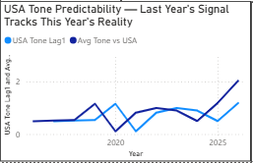
- The two lines diverge dramatically in 2024. Iran Tone Lag1 (based on 2023 data) was still positive — suggesting no reason to expect a crash. Yet Avg Tone vs Iran in 2024 collapsed to −2.33. This is the core limitation of any lag-based predictive model applied to Iran: the worst outcomes arrive without prior diplomatic warning in the data. The only available signals are economic (oil price movements) and geopolitical event monitoring (Gaza, Iran-Israel strikes).
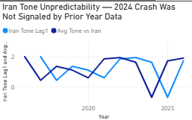

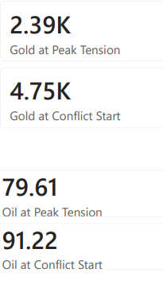
Section 5 — Economic Signals
- Gold at peak tension: $2,390/oz → Gold at conflict start: $4,750/oz — markets priced in the conflict years early
- Oil at peak tension: $79.61 → Oil at conflict start: $91.22

- Dubai crude price movements aligned with Iran tone deterioration — economic stress anticipated diplomatic breakdown
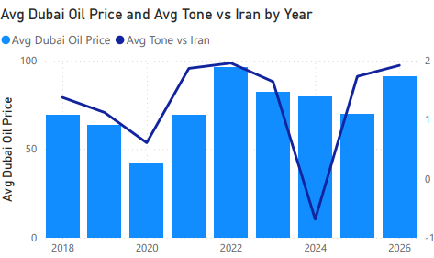
- This is the economic early warning chart. Dubai crude (bars) and Pakistan-Iran tone (line) move in inverse relationship: when Iran tone falls, oil price rises. The 2024 crash in Iran tone coincides with elevated oil prices. The post-2024 recovery in Iran tone coincides with oil prices stabilizing. This is the market pricing in the exact diplomatic dynamic that the GDELT data captures — independent confirmation from two completely different data sources.

- Pakistan petrol prices tracked the US-Iran Tension Proxy — frontline states absorb commodity shocks before formal conflict declarations
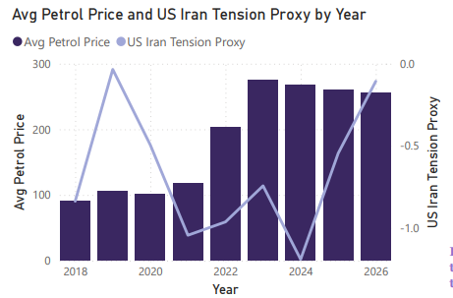

Gold price and the Conflict Risk Score peak in the same year — 2024. This is the key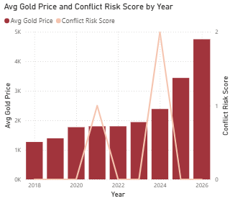convergence finding. Two completely independent indicators — commodity markets and a GDELT-derived diplomatic model — identified 2024 as the peak risk year simultaneously. The convergence of economic stress and diplomatic deterioration in the same window is the core argument of Section 6.

Section 6 — Composite Risk Index
- Peak Risk Year identified: 2024; Warning lead time: 25 months
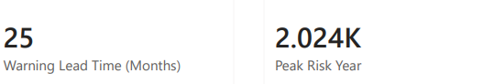
- Economic stress and diplomatic deterioration converged in the same window — the convergence pattern is historically reliable.
- The steady rise from 2018 to 2026 is the economic narrative of an escalating conflict. Each bar represents accumulated commodity stress — oil prices, gold prices, Pakistan petrol prices — in that year. The acceleration after 2022 matches the beginning of the Gaza conflict buildup. The 2026 bar being the longest is sobering: active war has pushed economic stress to its highest recorded level.
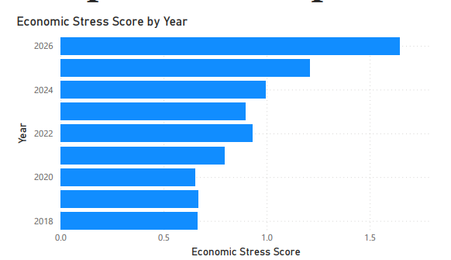
- This is the synthesis chart. Three data streams: the economic-diplomatic composite index, Iran tone, and USA tone. When all three deteriorate together — as in 2024 — the framework identifies maximum risk. The visual separation between the Iran tone line (crashing) and USA tone line (holding) in 2024 is the mediation window closure shown in economic terms. The recovery of all three lines from 2024 to 2025 represents the ceasefire and diplomatic rebound.
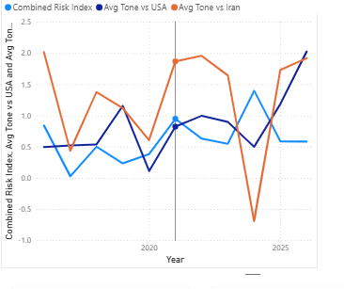

Section 7 — Monthly Model vs Annual Model

Annual Model — 2024 Detection
● Pre-Crisis Warning Score spiked to +3 in 2024 — the highest annual reading in the dataset. This was driven by both Iran and USA tone deteriorating simultaneously while the tension proxy worsened.
● All four composite measure conditions reached their worst readings in the same year. This is the model's strongest retrospective validation: it correctly identified 2024 as the peak risk year, which preceded the 2026 conflict by 25 months.
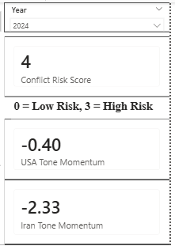

Monthly Model — June 2025 (Twelve-Day War)
● June 2025: Iran Momentum Monthly −1.67, USA Momentum Monthly −0.34, Conflict Risk Score 2. Both momentums negative simultaneously in the exact month the Twelve-Day War began (June 13, 2025). Concurrent detection.
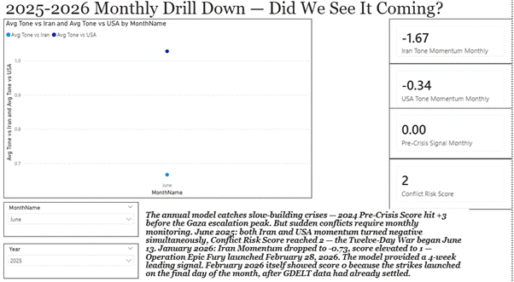
● May 2025 leading signal: USA Momentum Monthly was already −0.69 in May — one month before the war. The USA relationship was deteriorating ahead of the conflict.
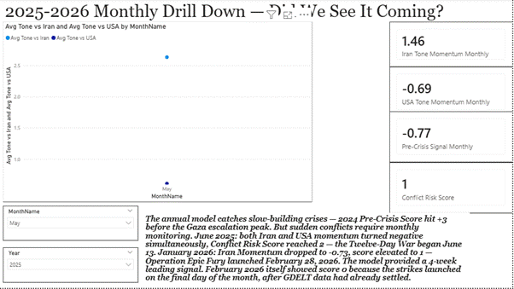
● The annual model shows 2025 as low risk (score 0, Iran +2.42, USA +0.69) because the post-war recovery dominated the full-year average. The monthly layer is essential for detecting this crisis.
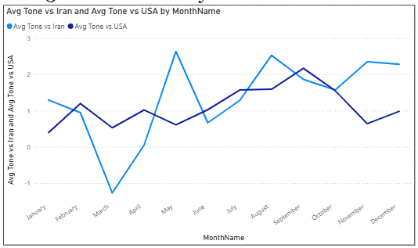

Monthly Model — January–February 2026 (Operation Epic Fury)
● January 2026: Iran Momentum Monthly −0.73, Conflict Risk Score 1. Four-week prospective leading signal before Operation Epic Fury launched February 28, 2026.
● The Pakistan hedging pattern: January 2026 simultaneously showed USA Momentum Monthly at +1.17. Pakistan was improving its USA relationship while Iran deteriorated — strategic positioning in anticipation of the conflict. The model scored 1 instead of 2 because the dual-negative condition was not met. This is a known scoring limitation: asymmetric momentum (Iran falling, USA rising) signals Pakistan hedging, which is itself a pre-conflict indicator.
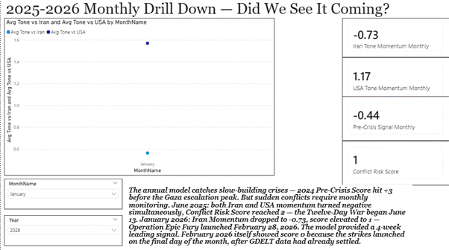
● February 2026 scored 0 because Operation Epic Fury launched on the final day of the month (February 28). Insufficient GDELT coverage had accumulated within February to move the monthly average. January is the correct detection month for this event.

Section 8 – Recommendations
● Build strategic energy reserves when Economic Stress Score exceeds 1.0 — oil and gold markets price in conflict before diplomatic declarations
● Apply "smart" consumption measures (as Pakistan did in March 2026) before supply chain disruption, not after
● Gradually adjust domestic energy prices to manage demand, avoiding sudden price shocks
● Diversify supply chains when monthly Conflict Risk Score reaches 2+ — this is the actionable business threshold
● Monitor Pakistan's diplomatic activation as a lagging confirmation: if Pakistan suddenly increases Iran-USA engagement, tension has already peaked
● Gold price trajectory is a reliable advance indicator — the $2,390 → $4,750 run-up happened over years, not days
● Mediation opportunities narrow sharply when the Mediation Window Score drops below 0.3 — that threshold should trigger emergency diplomatic engagement
● Pakistan's reactive mediation pattern means it needs external prompting to engage early — bilateral pressure from either the USA or Iran during rising tension periods could shift this from reactive to proactive
● Traditional conflict monitoring watches the adversaries directly — US and Iran bilateral signals. This analysis demonstrates that Pakistan's positioning between them encoded the crisis 25 months earlier than the actual conflict. Intelligence agencies, think tanks, and policy institutions should build mediator-state monitoring dashboards for every major adversarial pair — not just US-Iran but India-Pakistan, China-Taiwan, and others where a neutral third party exists with positive baseline tone toward both sides.

